Project working explained with screenshots

1. The project is created in the Windows Form of Visual Code environment using C# programming language.

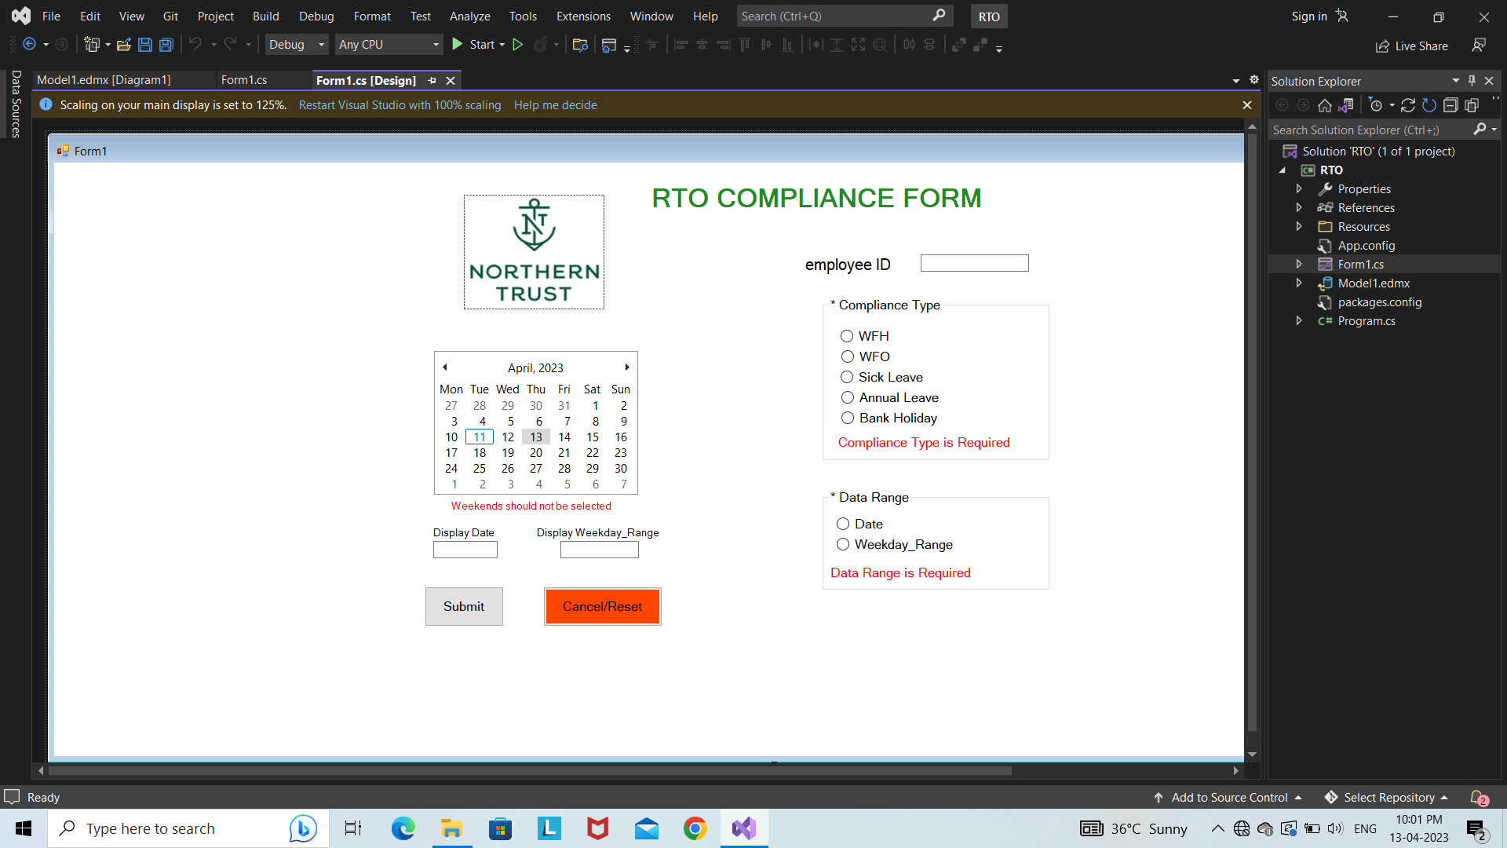

1. Using Microsoft SQL Server Management Studio as database.

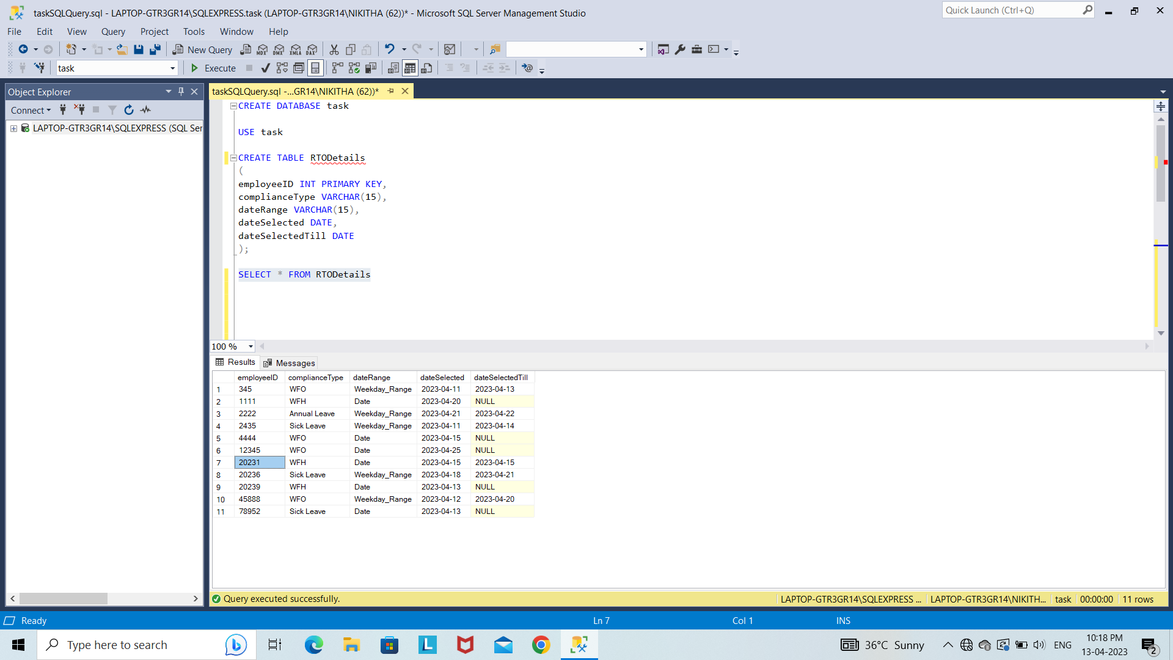

1. Code to connect with the database.

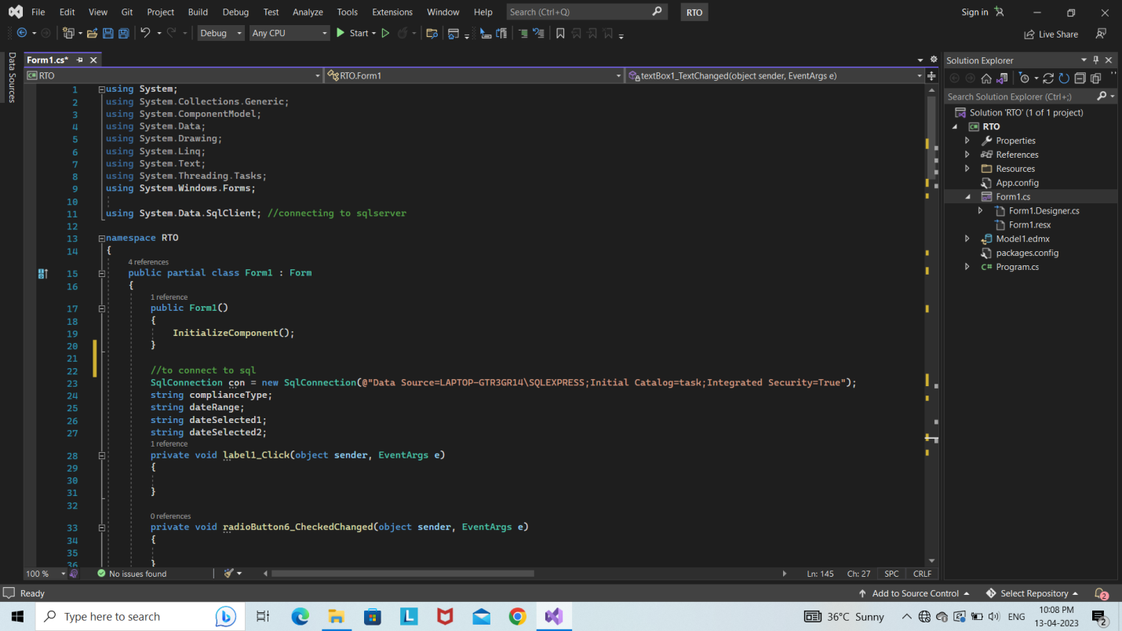

1. Code to select Compliance Type using radio buttons.

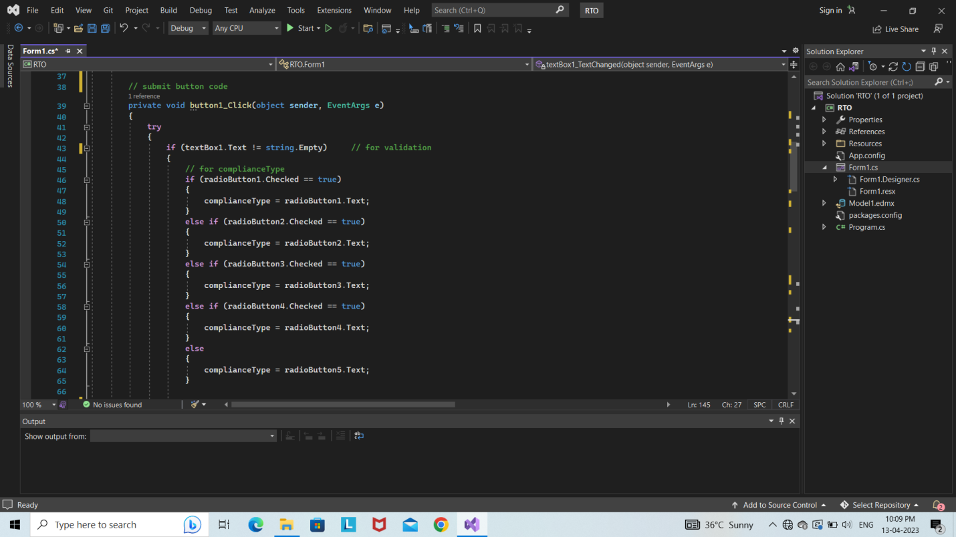

1. Code to select Date Range using radio buttons.

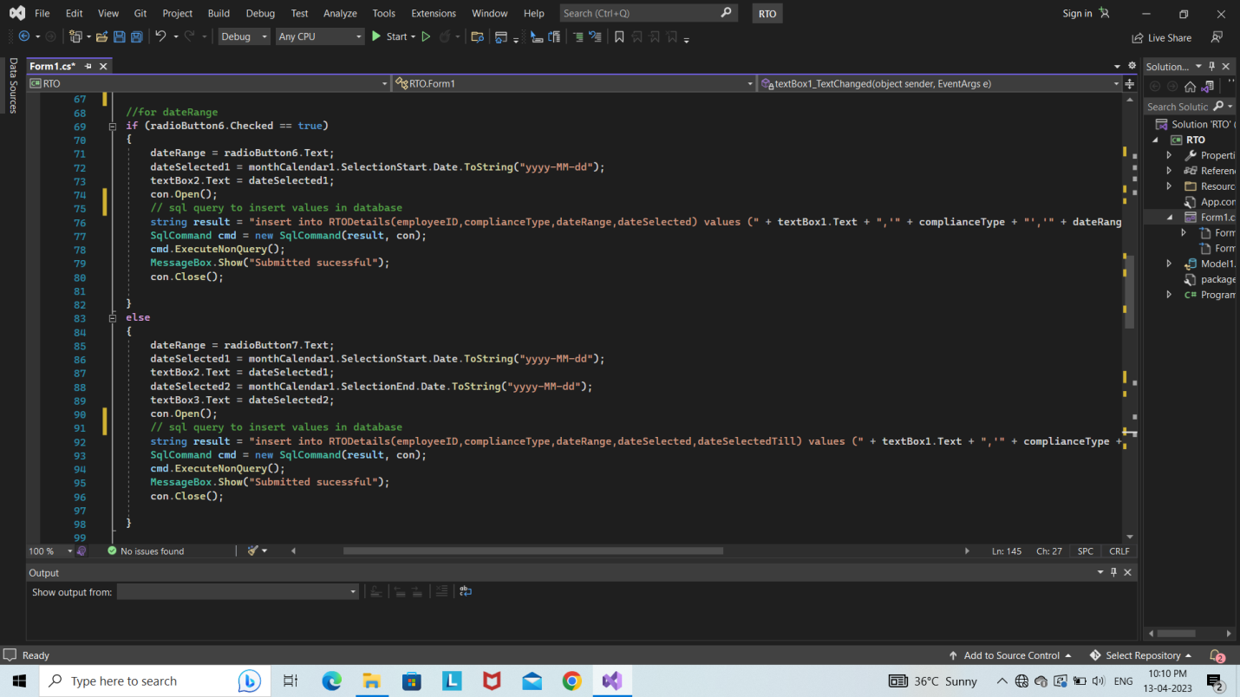

1. Code for Cancel/Reset button and employeeID textbox input condition.

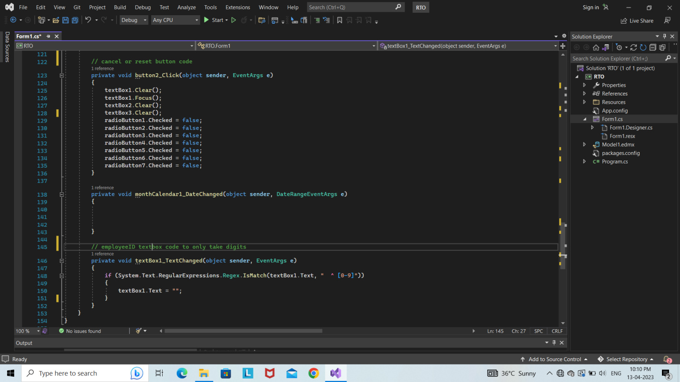

1. Clicked on submit button without filling the values will display a validation message.

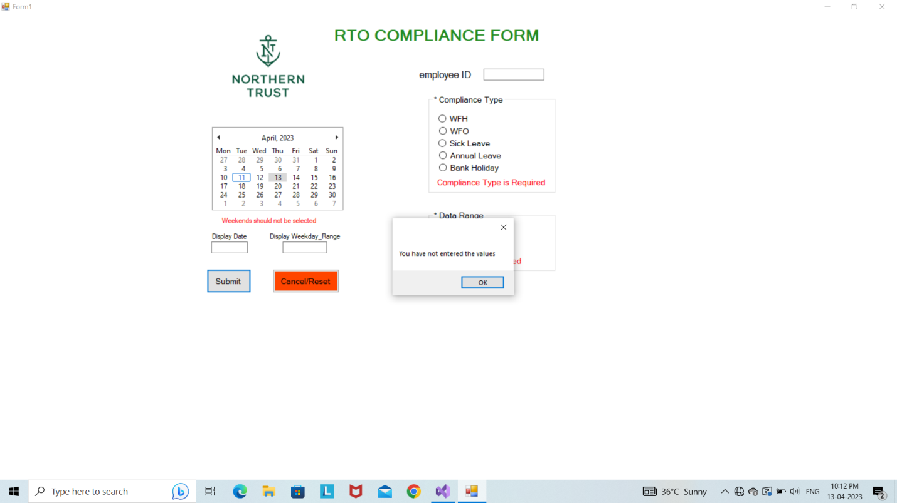

1. Successful submission of data.

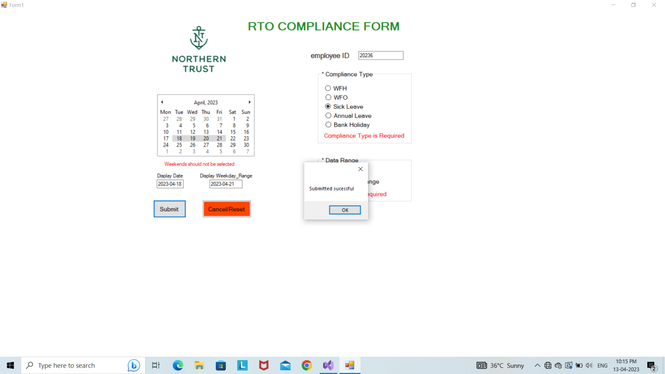

Data Visualization Report

1. Data visualization using Power BI.

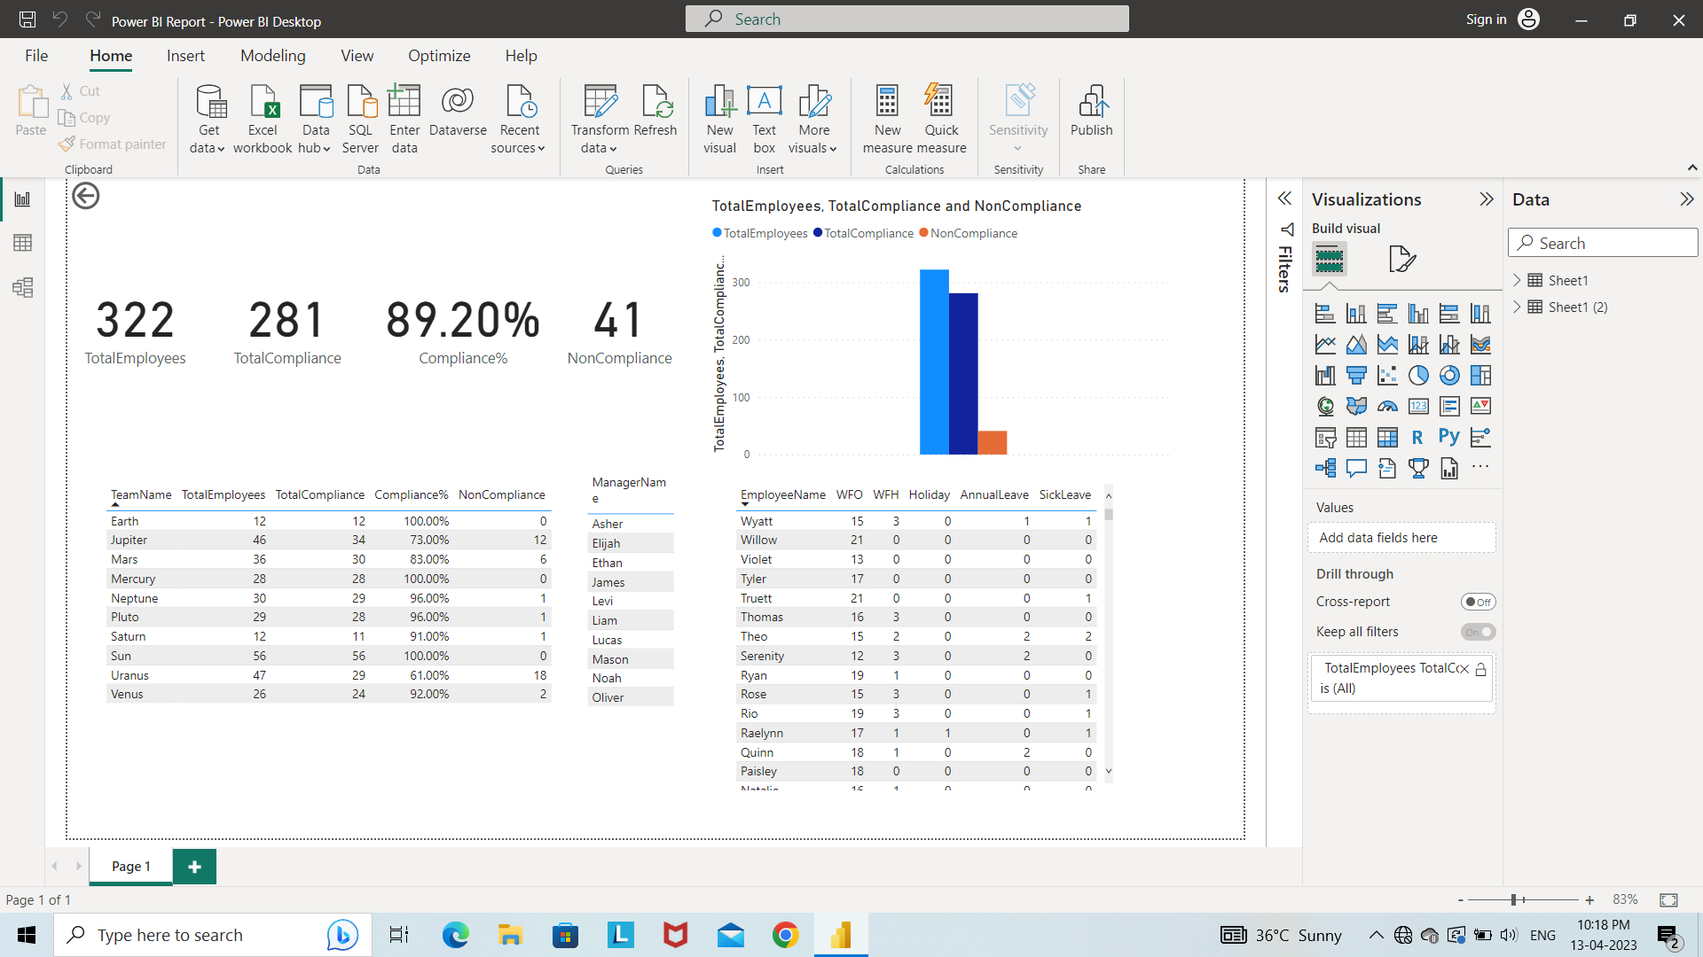

1. Dataset taken from Excel.

